**Software Engineering Assignment**

### MODULE: 1 (SDLC)

1)What is software? What is software engineering?

Ans-

software is collection of data ,information and providing instruction.software engineering is developing, testing and deploying software applications .

2)Explain types of software.

1)System software

-to run a computer's hardware and application programs.

Ex:-

**-Windows, mac, android, linux, ubuntu**

|  |  |  |  |
| --- | --- | --- | --- |
| **- Operating System**   |  |  |  | | --- | --- | --- | |  |  |  |   2)Programming software  Communicat to human to computer and machin language.  3)Application software  1) Mobile Application-  - use in mobile phone  Ex-graphic software  2)desktop Application-  -Use in pc/laptop  Ex-MS office  3)web Application-  -All web browser   * Ex- Chrome,Safari   4)Driver software-  -A hardware device communicate  with software devices  Ex-video driver  5)Middelware software-  -Middelware is connect the all device connect needs the software devices  2)What is SDLC? Explain each phase of SDLC  Ans-  -The Software Development Life Cycle (SDLC) –  process that of high-quality, low-cost software  -SDLC Life Cycle- |
|  |

1)Planning :-

-The programmer is plan the software of customer requirement.

2)Analysis-

* information from the client requirements for the software. It is analys the plan and collect the information in Analysis.

3)Design:-

a stage planing the desing of the software and start the making the software.

4) Implementation-

-This phase is initiated after the system has been tested and accepted by the user.

5)Testing-

verify and validate the functionality of the software developed before its

deployment and to recommend any improvements.

6)maintenance-

delivered product or service client's requirements and expectations

3) What is DFD? Create DFD of flipkart ?

Ans-

DFD is data flow diagram.

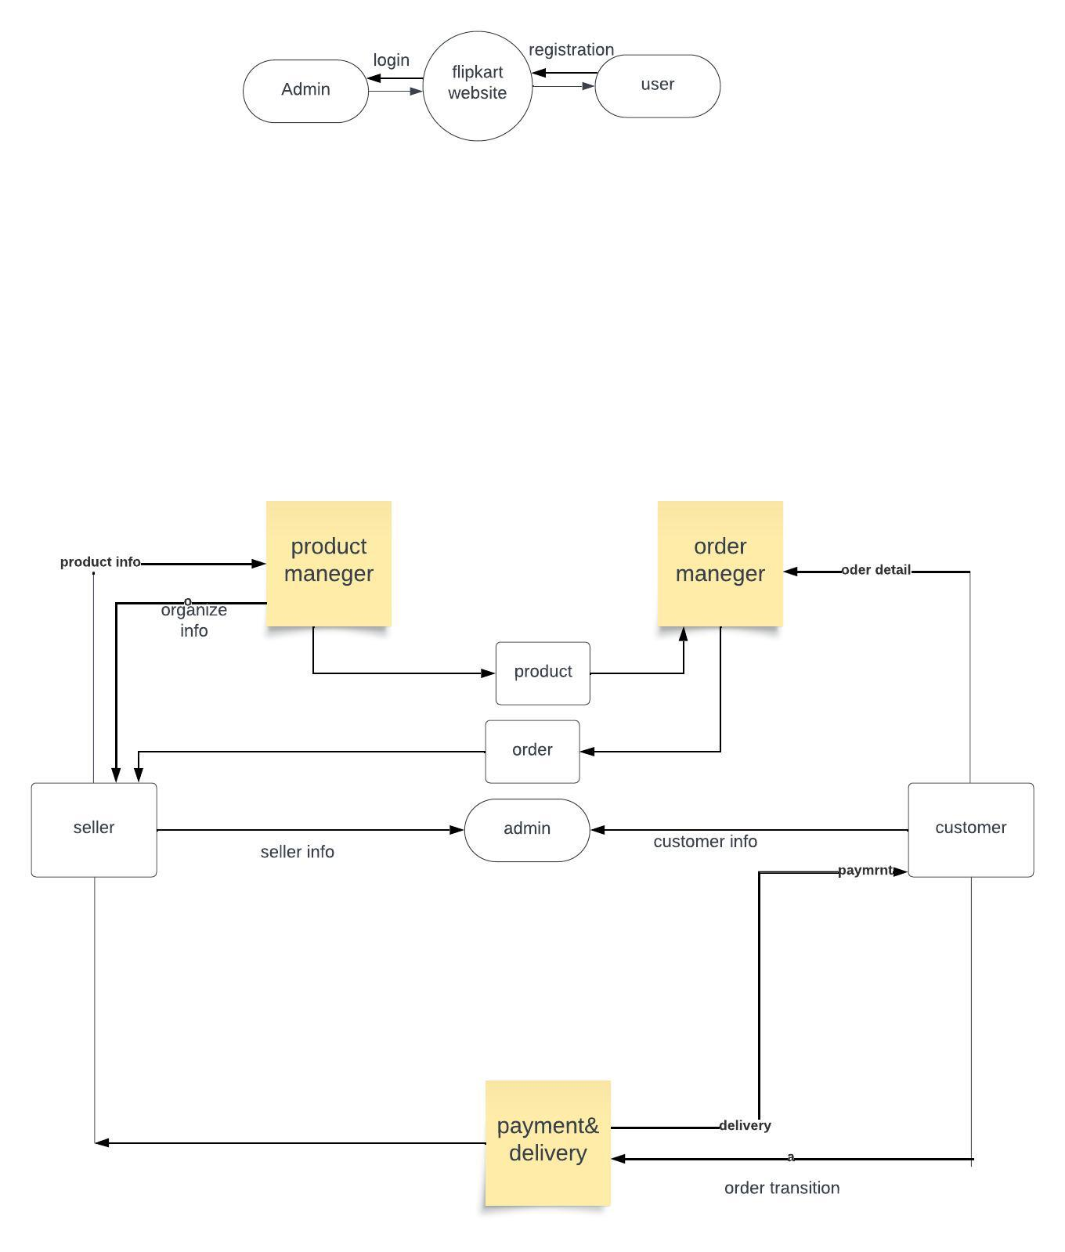

4) what is flow chart?create a flowchart to make addition of two numbers.

Ans-

Flow chart is sequence of logical steps

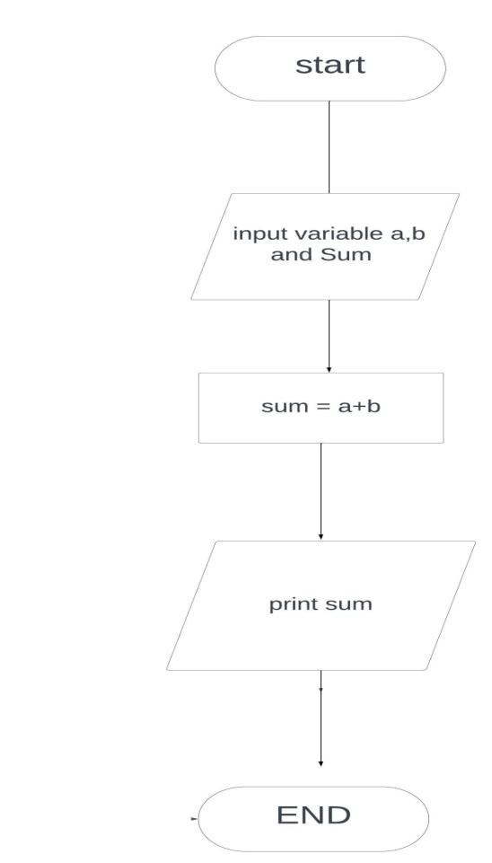

5)what is use case diagram? Create use-case on bill payment on payment.

